- Are planning and implementation time entries still entered separately?

Answer: Planning time (indirect time) for all staff should be entered for the service under the applicable performance measure using the prevention data portal forms. The form should be saved as a draft. If planning time is accrued for a service/activity that does not have a current goal/objective or performance measure under the project being funded, the time should be recorded for all staff and submitted monthly on the Excel spreadsheet and uploaded into GMS under the Admin Time/Planning time goal.

Example: Health Fair is set for a future date three months out. All indirect time (planning time for staff and volunteers) should be entered as it occurs in a service form for the Health Fair. The form should be updated and saved as a draft until the event occurs and all final data is entered. At that time, the form should move from draft status to submitted.

If a county agency has a meeting established with the superintendent of the school district to discuss implementing an educational multi-session program in the future but there are currently no goals, objectives and performance measures to link the time to in the project, that time should be noted under the appropriate CSAP strategy are in the Excel spreadsheet and uploaded into GMS under the Admin Time/Planning goal for the all staff monthly.

Planning time for projects funded through other grants (AET COVID-19, Primary Prevention Enhancement Grant, etc.) can be recorded on the Excel spreadsheet as there are no goals/objectives and performance measures in which to record this information in the GMS system. The GMS system is set-up by projects that are linked back to funding streams. Currently DAODAS only has the SAPT BG projects in the system (Primary Prevention and AET) along with the prevention state funds.

- If I write a newsletter, I don’t technically have direct time, do I? How do I enter this time in the new system?

Answer: The time to prepare a newsletter (handout/brochure/etc.) would be entered as indirect time in the form for that service. Zero would be entered for the direct hours and minutes as these are required fields.

- Several services target multiple objectives. It would be helpful to be able to select multiple objectives like we did with IMPACT. If we are targeting two different objectives, do we have to make two entries for that service?

Answer: The service information should go under the appropriate objective. For example, if you conduct a health fair for 3 substances, you can choose to place the information in the data portal in 3 different objectives (dividing the total number served by 3 and entering a third of the information into each objective) or you can enter one health fair in the alcohol objective this service implementation and for the next one, enter it into a different objective.
For example: If there were 300 people in attendance at the health fair, you could place 100 under the underage alcohol health fair objective, 100 under the tobacco health fair goal and 100 under the prescription drug objective OR you can enter all three hundred people under the alcohol health fair objective for this service event and then enter the next health fair that you conduct under tobacco, etc. Ultimately the numbers will all be counted as individuals you served during the year, so we do not want to double or triple report data. DAODAS will explore the ability to select multiple objective in the future.

In addition, if Deterra or Lockboxes are provided at the health fair, the number of deterra bags and/or lock boxes should be entered into the correct environmental forms. You can enter the staff time (direct) as zero-if it has already been captured under the health fair entry. The indirect time can be entered to reflect the time you spent preparing the bags/boxes for distribution.

- Why can the planning of the activity not be submitted for reimbursement until activity completion?
Answer: Planning time can be submitted each month as DAODAS will be able to see any service forms that are saved as drafts as well as those that have been submitted.
- How will admin leave/time (FMLA, sick, PTO, maternity, SCAPPA Leadership, SCAPPA Mentorship, Certification, CARF, and other required agency and state meetings/committees, etc.) be reported for reimbursement?

Answer: Administrative time will be captured in an EXCEL spreadsheet and uploaded into GMS monthly. Please capture all administrative time for all staff members supported through the SAPT BG primary prevention set aside on one Excel spreadsheet for the agency. Save the file by indicating the month and the year (July 2022). Upload the file into GMS under the Administrative time goal by double clicking on the performance measure and then clicking on the attachment tab.

- If agencies meet all their deliverables and draw down their block grant before the end of the FY, does DAODAS still expect them to be inputting data into the GMS?
Answer: The data reported through GMS and the DAODAS prevention portal should reflect the services supported through the SAPT Primary Prevention Block Grant funding. If an agency receives additional funding for prevention services from DAODAS such as supplemental funding, discretionary grants, etc., the agency should report as indicated through the contract/grant award.
- Are the feds requiring the 6 CSAP strategies to be broken out in the way it is set up in the GMS, or was this a DAODAS decision?
Answer: The SAPT BG requires DAODAS to report the financial information by the 6 CSAP Strategy areas- DAODAS has always been reporting this way, however, we are looking to improve our accuracy of reporting this information as we make this transition to the GMS.
- If next year an agency does not want to work on but 4 CSAP strategies, are they able to do so?
Answer: Absolutely. An agency has always had the ability to submit a request for an exemption if they are not able to provide services related to any of the CSAP strategy areas. As a state, SC is required to ensure services are provided in each of the 6 CSAP areas, however, that does not mean that each local entity has to address each strategy area. Reasons to request an exemption can be related to capacity (fiscal or staffing), potential duplication of service efforts if there are other organizations in your community providing similar strategies, need for the strategy is not identified through the local need’s assessment, etc. If you have any questions, please contact DAODAS.
- DAODAS said they will reimburse us based on doing activities with the CSAP strategies. Someone asked (and I was thinking the same) what about if someone goes on maternity leave, and she said she will have to address that on a case-by-case basis (indicating it’s not a guarantee for reimbursement).
Answer: Maternity or any other type of long-term leave would be captured in administrative time and DAODAS will reimburse the agency for salary/fringe of the portion of the person supported through the SAPT BG primary prevention set-aside.
- Will we be able to enter indirect & direct time greater than a 24-hour time period when we are entering the activity – for example: I conducted a community event that lasted 4 hours of direct time but took 30 hours of indirect (planning) time & when I enter it – it will add up to more than 24 hours.
Answer: Yes-that is possible
- What is the reason for only allowing DAODAS to make edits to services already entered? Not being able to change entries once they are submitted doesn’t allow for human error. That seems like something we should have access to take care of. A lot of time will be wasted when we have to contact DAODAS every time we make a small mistake.

Answer: Forms can be saved as “drafts” and reviewed by the agency as a part of the agency’s continuous quality improvement measures before they are submitted to DAODAS. If a mistake is found after a form is submitted, there will still be a way for the data to be corrected by having DAODAS open the form for edits.

- What is the reason for the substances being specified? This seems like going backwards. Also, not being able to select multiple objectives makes for inaccurate reporting. We are covering all the substances when we are out in the community and only selecting one is inaccurate reporting.
Answer: The SAPT BG Goals are substance specific based on the State’s needs assessment. Please see additional information under question #3 for additional information.
- What is going on with Admin (i.e. leave) time? Is there still a requirement for hours—if so we need to be able to report this?

Answer: Administrative time will be captured in an EXCEL spreadsheet and uploaded into GMS monthly. (see question #1 for more information)

- What is the plan for reporting?

Answer: Reporting requirements have not changed- the expectation is that service data and admin time should be submitted by the 8th working day of the month for the previous month. DAODAS understands that reporting for the first quarter (July-September) may not be entered until later in the year, but hopefully by end of January, all sites will be caught up with reporting for services conducted during the first quarter (July, August and September). As you are entering data, please start with October/November and work your way backwards as time allows.

- What is supporting the shift in us having to attach monetary amounts to everything?
Answer: Please see question #7 for more information.
- How will AET Coordinators enter their activities for different counties and then how will that be connected to the agency’s objectives.
Answers: AET Coordinators will have access to all of the projects related to the counties that are in their circuit. Agencies will continue to have the choice of how/who enters the service data for each county. That has not changed from the previous requirements/guidance.

- I am also wondering since we are no longer being required to document admin time in the system if there is still going to be a 150-hour requirement or if we should readjust percentage of time for CSAP strategies to accommodate for percentage of time that would be admin time. How will this be done? Is there a mechanism already in place?
Answer: There is no 150-hour requirement. Administrative time will still be documented in GMS-see answer for question #7. It will not be documented in the Prevention Data portal.
- Please clarify how many users per agency can have access to the prevention component of the GMS.
Answer: As many as an agency needs will have access to the prevention data portal.
- How many portals are as component of the GMS system, who has access to each portal, will there be a different log-in per user per portal?
Answer: There are three components to the GMS system-Pre-award (funding announcement/application portal), post award (management of active awards to include deliverables and reimbursement requests) and the DAODAS prevention data collection portal that is connected to the post award portal to collect specific data/information required for SAPT BG federal block grant reporting. The GMS pre-award portal- each agency should have a login to access the portal and work on funding announcements. Agencies can assign individual users as needed to their account in order for applications to be completed. For the post-award portal, DAODAS is requesting each agency submit 4-5 individuals that will need access to the portal for reporting and overall grant management. For multi-county agencies, DAODAS is working with agencies that may need additional logins. The DAODAS prevention portal can have multiple users with individual users (just like IMPACT and the EPRS had).

- If an agency does not meet objectives such as education, will money not be paid or distributed?
Answer: If you hit a roadblock, and are unable to meet initial education deliverables, you can make a budget request to move money to another objective such as information dissemination.

- Does the reference ID take the place of the old service codes?
Answer: Yes, but not 100% the same. The reference ID will match your objective. PR-ID-UDP-SpE-UAD = Information Dissemination - Speaking Engagements - Underage Drinking

- Will it be like Impact where we just type in what we do for mid-year and year end objective? If we do a quarterly or monthly report, will we go back in to add more information or do we just go in and update the number?
Answer: Yes, you just go in and update the number. For example, in Q1 you enter “20” Q2 you have another 20, which would be changed to 40. DAODAS is requiring the performance measures labeled actual to be updated at a minimum twice a year. Mid-year (in January for services conducted during first have of fiscal year) and Year-End (to reflect the entire year of service). Agencies can require the numbers to be updated as often as you like-after service event, monthly, quarterly, etc.

- Once a form is submitted, is there an easy way to modify forms in the case of an error, such as duplication?
Answer: No, but you can email DAODAS (prevention@daodas.sc.gov) to make any edits or to remove duplicate forms for example. In the portal, you can view draft forms before they are submitted.
- Does DAODAS make individuals “inactive” when they no longer need access to the data portal?
Answer: Yes. When there are staff changes at the local level, agencies will need to inform DAODAS in order for changes to be made to logins.

- Would a key officer meeting go in admin time?
Answer: No, it would be captured as direct time under the coalition meeting. Prevention staff time for attending the state AET Coordinator’s Meeting or Prevention Quarterly meetings would go on the Excel spreadsheet as administrative time.
- Is there going to be information regarding how to download reports?
Answer: Yes- there will be future trainings held once the reporting features are complete.

Direct | Indirect | Administrative
- Face to Face service time with the audience; time spent delivering services to audiences.  - Time spent attending meetings, trainings, conferences, etc. would not be direct time, and may not be indirect time if the activity attended does not have a direct relationship to program goal and objectives outcomes.  - Service duration=direct time (if you spend 1 hour teaching an All-Stars class, the service duration would be 1 hour and your direct time would be 1 hour).  - The travel time, preparation time, etc. would be indirect and not a part of the service duration. | - Planning/consultation for implementation of programs/strategies  - Evaluation of programs/strategies  - Travel involved with delivery of programs/strategies  - Marketing/Recruiting for implementation of programs/strategies  - Assisting another staff member with preparation for implementing programs/strategies | SCAPPA Supervision (Providing supervision for employees related to certification-mentoring, study/interview preparation, etc.)  SCAPPA Certification (training, mentor hours, paperwork, test preparation, testing, etc.)  - SCAPPA Leadership (Serving on SCAPPA Certification Commission, Board and/or committees)  CARF related meetings/trainings  - Internal Meetings (general staffing meetings, agency meetings, etc.)  Leave  Annual leave  Sick leave  Jury Duty  - Leave Without Pay  - Other  - Agency Assigned duties not related to the implementation of Prevention Services  - Professional development (trainings not related to a specific program/strategy) such as conferences that cover general prevention topics, etc.  *Do not enter Administrative hours  for volunteers.

Entries should reflect direct and indirect time for all staff and volunteers that worked on the implementation of the service
Don’t forget to enter time for each volunteer. For example, if Sunny county Sheriff’s Department spent two hours conducting tobacco compliance checks and there were two teams of two officers, the total amount of direct hours entered under each Sunny County Sheriff’s Deputy would be 2 hours but you would need to have deputy 1, 2, 3 and 4 to capture the time accurately or if you are tracking all of the volunteers under the department, make sure to multiple the total hours by the number of officers. For example, if there were 4 officers from the Sunny County Sheriff’s Department and the checks took 3 hours to conduct, the total amount of direct time entered should be 12 hours.
Target Population should reflect the population is impacted by the service. If there were multiple target populations impacted, select the primary target population and make a note of the others served in the “Description” field.
‘ Location Name’ should reflect the place that the service is conducted.
‘Service Counts’ and ‘Demographics’ are required for all implementation service codes.
Total number served field must be completed (along with the demographics that reflect the number served) before a form can be submitted. The total number served, and demographics can be left blank as indirect time is being entered and the form is in draft. Once the event is held, those fields must be completed before the form can be submitted.
Provide a brief but adequate ‘Description’: For example, if you conducted Session 6 of All Stars at Shay Day School, activity description should not read, “Shay Day School”.

Forms that require demographics
Alternatives: Alternative activities and programs redirect individuals from potentially problematic settings and activities to situations free from the influence of ATOD.
Alcohol and Drug Free Social and Recreational Events: Alternative activities and programs redirect individuals from potentially problematic settings and activities to situations free from the influence of ATOD. (Ex: After Prom Party, 5th Quarters, Tailgate, Halloween Carnival, etc.)
Indirect Time: Planning for alternative activities and programs, setting up logistics for the event, paperwork, travel time. Etc.
Team Building Activities/Ropes Courses: Hands on experience that focuses on the growth of the participant (youth, adults, business, community) through team building, leadership, problem solving, etc. (Ex: Ropes Course)
Indirect Time: Planning for team building activities and ropes courses, setting up logistics for the event, paperwork, travel time. Etc.
Information Dissemination:
Speaking Engagements: One-time events that provide information to an audience (in-person or virtual) to convey information on a particular issue/substances. Record number and demographics of people present at the event.
Indirect Time: Record time spent preparing for event (research, power point/material development), setting logistics for event, paperwork.travel time to and from the event, evaluation and reporting, etc.
Health Fairs and Other Health Promotions- Events/drive thru events in which information is provided to the public. Count should reflect number of people that participated in the event (visited the table/booth, drove thru the event, etc.) Record number and demographics of people visiting the table and receiving information.

*NOTE: If Deterra is provided at the event, please environmental section for information about how to capture the Deterra dissemination separate from the event. travel, set-up/breakdown of the event, evaluation and reporting of the event, etc.
Indirect Time: Record planning time to include material preparation, meetings to plan event, marketing of event, travel, set-up/breakdown of the event, evaluation and reporting of the event, etc.
Town Hall Meetings-Town hall meetings are events held to provide information to the public about substance use. The primary purpose of town hall meeting is to mobilize the community around prevention efforts and empower people to be a catalyst for change. The meeting should move people beyond awareness to action. The meetings can be in-person or virtual. Record number and demographics of people in attendance at the meeting.

Indirect Time: Record time preparing for event to include publicizing event, meetings, preparing materials, locating speakers, travel, set-up/breakdown of the event, evaluation and reporting of the event, etc.

AET Casual Contacts- Visits to retail alcohol establishments to remind clerks of their role in preventing underage drinking, the SC laws related to underage drinking, etc. Visits can also be to local high schools to have informal conversations with youth to remind them of the laws/consequences of underage drinking (Chatting with you during lunch period before prom, homecoming, spring break, etc.). This is not a formal speaking engagement/presentation. Those activities would go under speaking engagements. Record number and demographics of people contacted.

Indirect Time: Record planning time related to contacts such as meetings to discuss locations to visit, material preparation, etc. Travel time to the locations, evaluation and reporting of the contacts, etc.
MADD Power of Parents- Presentation of the MADD Power of Parents program to an audience. Record number and demographics of people in audience for the presentation.

Indirect Time: Record planning time related to setting up the event, preparing materials/handouts for the event, travel, set-up/breakdown of the event and evaluation/reporting of the event.

MADD Power of Youth-Presentation of the MADD Power of Youth program to an audience. Record number and demographics of people in audience for the presentation.

Indirect Time: Record planning time related to setting up the event, preparing materials/handouts for the event, travel, set-up/breakdown of the event and evaluation/reporting of the event.

Clearinghouse/Information Resource Centers- Provision of information to the general public through resources that are provided or loaned through the agency such as videos, workbooks, brochures, visual aids, etc. Record number and demographics of people visiting the resource center.

Indirect Time: Record time related to staffing and stocking the resource center. Development of new documents and/or ordering new materials, etc.

Education:

Education Services for Youth-Provision of multi-session education programs (curriculum-based) evidence-based or non-evidence-based for youth in schools or other community settings. Record total number of people in attendance at each session and demographics of those individuals. Direct time is reflected as the face-to-face time teaching the curriculum.

Indirect Time: Record time related to planning/meeting with the school/other community setting partners to set-up the service, reviewing and preparing the lesson plans, travel time, evaluation and reporting.

Education Services for Adults- Provision of multi-session education programs (curriculum-based) evidence-based or non-evidence-based for adults in community settings. Record total number of people in attendance at each session and demographics of those individuals. Direct time is reflected as the face-to-face time teaching the curriculum.

Indirect Time: Record time related to planning/meeting with the community setting partners to set-up the service, reviewing and preparing the lesson plans, travel time, evaluation and reporting.

Parenting and Family Management- Provision of multi-session education programs (curriculum-based) evidence-based or non-evidence-based for families in schools or other community settings. Record total number of people in attendance at each session and demographics of those individuals. Direct time is reflected as the face-to-face time teaching the curriculum.

Indirect Time: Record time related to planning/meeting with the community setting partners to set-up the service, reviewing and preparing the lesson plans, travel time, evaluation and reporting.

Problem Identification and Referral:

Tobacco Education Program- Provision of the DAODAS-approved tobacco education program for youth violating minor in possession law and/or school policies as it relates to tobacco/vaping. Record total number of people in attendance at the session and demographics of those individuals. Direct time is reflected as the face-to-face time teaching the curriculum.

Indirect Time: Record time related to planning/meeting with the community setting partners to set-up the service, reviewing and preparing the lesson plans, travel time, evaluation and reporting.

Tobacco Cessation Program- Services provided to assist adults with their plans to quit using tobacco products in the agency or other community setting. Record total number of people in attendance at each session and demographics of those individuals. Direct time is reflected as the face-to-face time providing the program.

Indirect Time: Record time related to planning/meeting with the community setting partners to set-up the service, reviewing and preparing the lesson plans, travel time, evaluation and reporting.

Diversion Programs- Services provided to those under 21 who been found in violation of a law or policy related to substance use (school/campus policy, Alcohol Education Program for underage drinking law violations, etc.) Record total number of people in attendance at the session and demographics of those individuals. Direct time is reflected as the face-to-face time providing the se.

Indirect Time: Record time related to planning/meeting with the community setting partners to set-up the service, reviewing and preparing the sessions, travel time, evaluation and reporting.

Employee Assistance Programs- Services provided to businesses on a contractual basis to support healthy staff and workplaces. (Ex: Policy Development, Workshops, Signs and Symptoms, Insurance, etc.) Record total number of people in attendance at the session and demographics of those individuals. Direct time is reflected as the face-to-face time providing the service.

Indirect Time: Record time related to planning the service, reviewing and preparing the sessions, travel time, evaluation and reporting.

Student Assistance Programs- A K-12 school-based, evidence-informed framework for prevention, early intervention, referral and support for students with needs that may prevent them from fully benefitting from their educational experience. SAPs focus on building supports for students dealing with non-academic barriers to learning including behavioral health, family and relationship issues as well as other life needs. Record total number of people in attendance at the session and demographics of those individuals. Direct time is reflected as the face-to-face time providing the service.

Indirect Time: Record time related to planning the service, reviewing and preparing the sessions, travel time, evaluation and reporting.

Community-Based Process:

Multi-Agency Coordination/Collaboration/Coalition Meetings-Coalition/Agency collaboration meetings only. Other strategies sponsored by a Coalition need to go under the appropriate strategy. Record total number of people in attendance at the meeting and demographics of those individuals. Direct time is reflected as the meeting time.

Indirect Time: Record time spent planning for meeting, creating agenda, typing minutes/reports, sending out email reminders, paperwork related to follow-up from the meetings, etc.

Youth Boards/Coalition Meetings- Youth Board/Coalition meetings only. Other strategies sponsored by a YAB or Youth Coalition need to go under the appropriate strategy. Record total number of people in attendance at the meeting and demographics of those individuals. Direct time is reflected as the meeting time.

Indirect Time: Record time spent planning for meeting, creating agenda, typing minutes/reports, sending out email reminders, paperwork related to follow-up from the meetings, etc.

Community and Volunteer Training and Technical Assistance- Conducting a training in which participants are learning a skill set. The trainings can be for agency staff, community partners, other prevention professionals, etc. Record total number of people in attendance at the training and demographics of those individuals. Direct time is reflected as the training time.

Indirect Time: Record time spent planning for the training event, sending out email reminders, registration, preparing materials, paperwork related to follow-up from the training, evaluations and travel time.

Recognition Activities- Stand alone event where volunteers and partners are recognized for their contributions to prevention efforts. Record total number of people in attendance at the event and demographics of those individuals. Direct time is reflected at the time of the event.
Indirect Time: Record time spent planning for the recognition event, sending out email reminders, registration, preparing materials, paperwork related to follow-up from the training, evaluations and travel time.

Environmental:

Compliance Checks-Law enforcement conduct checks to test the obedience with underage drinking laws that require retail personnel to check the buyer’s age (ID) and not sell alcoholic beverages if the purchaser is less than 21 years old. In the "Description" field, state all that apply: Number/Type of violations written/fine. Law enforcement conduct checks to test the obedience with underage tobacco laws that require retail personnel to check the buyer’s age (ID) and not sell tobacco products if the purchaser is less than 21 years old. (SC law is still 18). Direct time is the time of the compliance check and record the demographics of the seller and the youth buyer.

Indirect Time: Record time spent planning the checks, travel time to and from the store, training the youth buyers, paperwork related to the checks, completing reports, court, etc. If multiple checks are completed in an operation (for example, 20 stores are checked in an evening), the total indirect time can be captured under the first check (for the buyers, law enforcement and prevention staff) and then you can enter a zero in indirect time for the remaining 19 checks, or you can total up the indirect time for the set of compliance checks and enter a fraction of the time under each check. For example, if there was 5 total hours of indirect time, you could enter 0 hours and 15 minutes under each compliance check.

Merchant Education- Provision of the Palmetto Retailers Education Program (PREP) to on and off-premise salesclerks, bartenders and servers. Direct time is the time spent teaching the curriculum. Record the demographics of the people in attendance at the class.

Indirect Time: Record time spent planning for the class, registration, emails confirming attendance, travel time, completing paperwork, evaluation of program, etc.

Synar Study- Record time associated with Synar store visits for all participants (staff, youth and adult volunteers, etc.). Direct time is the time associated with each check. Record the demographics of the youth buyer and seller.

Indirect Time: Record time spent planning Synar visits to include paperwork, recruiting and training volunteers, travel time to the locations, completing the reports, etc.

Controlled Party Dispersals- Enforcement efforts related to properly disperse a party in which participants under 21 have been consuming alcohol. In the "Description" field, state all that apply: Number/type of violations written; area where patrol was conducted. Direct time is the total time of the operation. Record the demographics of the people in attendance at the party.

Indirect Time: Record time spent meeting to plan the dispersal operations, paperwork, travel time, completing reports, court. etc.

Public Safety Checkpoints/Saturation Patrols- Public Safety Checkpoints are used by law enforcement to detect and apprehend impaired drivers. In the "Description" field, state all that apply: Number/type of violations written; Area checkpoint was conducted. Also known as a “roving checkpoint”. Saturation patrols focus on a geographic area of a jurisdiction and may move around the enforcement unit(s) throughout the area-not stationary like a checkpoint. In the "Description" field, state all that apply: Number/Type of violations; Type written; area where patrol was conducted. Direct time is the total time of the checkpoint or saturation operation. Record the number of cars and the demographics of the drivers.

Indirect Time: Record time spent planning the operation, paperwork, travel/set-up time, completing reports, court, etc.

Shoulder Taps- The youth will approach strangers in retail alcohol outlet parking lots and ask then to purchase alcohol for them (after they have clearly identified they are underage and cannot buy it themselves). Law enforcement will supervise the youth and will only interact with individuals who make the purchase and transfer the alcohol to the minor (or if the minor is in danger). In the "Description" field, state all that apply: Number of buys/transfer of alcohol to minor cases written; Number/Type of violations written/fines. Direct time is the total time of the shoulder tap operation. Record the number of people approached and the demographics of those individuals approached by the youth.

Indirect Time: Record time spent planning the operation, paperwork, training the youth, travel time, completing reports, court, etc.

Bar Checks/Fake ID Sweeps- Law enforcement conduct checks of patrons at establishments to determine if fake/fraudulent ids are being used by patrons to enter the establishment and/or to purchase alcohol. In the "Description" field, state all that apply: Number/Type of violations written. Direct time is the total time of the bar check operation. Record the number of people approached and the demographics of those individuals approached.

Indirect Time: Record time spent planning the operation, paperwork, training the youth, travel time, completing reports, court, etc.

FORMS that DO NOT Require Demographics:

Information Dissemination:

Social Media Postings-

Indirect Time:

Media Campaigns-

Indirect Time:

Radio and TV Public Service Announcements-

Indirect Time:

Brochures, Factsheets, Newsletters and Handouts-Information provided to the public outside of an event. Items could be mailed out (email or snail mail), provided in waiting room at the agency or another partner agency’s waiting room, provided to parents through school events, etc. Demographics are not required- just total count of information distributed.

Indirect Time: Record time to design document and prepare it for dissemination (mailing, delivering to other agencies, etc.), travel time, evaluation/reporting, etc.

Community-Based Process

Systematic Planning-Activities that support networking, relationship building, and community engagement. Direct time-record total number of hours spent conducting the planning. Demographics are not required- just total hours spent on the activity.

Indirect time- Record time spent preparing for meetings, paperwork, travel time, etc.

Needs Assessment- Time spent conducting needs assessment activities such as surveys, focus groups, key informant interviews, etc. Record total number of hours spent conducting the needs assessment activities. Demographics are not required-just total time spent conducting needs assessment activities.

Indirect time- Record time spent preparing survey instruments, logistics for completing the needs assessment activity, review and processing of the data collected, paperwork related to the activity, emails, meetings, etc.

Accessing Funding/Grant Writing – Time spent researching and writing grants. Record the total number of hours spent researching and writing the grant(s). Demographics are not required-just total time.

Indirect Time: Record time spent in meetings discussing grant application, emails, etc.

Environmental:

Prescription Drug Deactivation Events- Time spent at the actual event distributing bags to the public. If this activity is completed in conjunction with a health fair/information dissemination event, count the number of people reached under the health fair service entry. (Those may be different numbers as you may provide more than one bag to a person and/or there may be people who do not need/take a bag, but attend the event.) Direct time is the time at the actual event distributing the bags. No demographics are required-just total number of bags disseminated.

Indirect Time: Record time related to planning for the distribution, paperwork, travel time, evaluation of the service, etc.

Prescription Drug Drop Boxes- Permanent receptacles located in designated law enforcement or pharmacies across the county to collect medication. No demographics are required-just total pounds collected by the agency through the dropbox.

Indirect Time: Record time related to providing assistance to law enforcement to maintain the dropbox, emails, paperwork, travel time, evaluation of the boxes, etc.

Prescription Drug Lock Boxes (storage)- Time spent at events distributing lock boxes to the public. If this activity is completed in conjunction with a health fair/information dissemination event, count the number of people reached under the health fair service entry. (Those may be different numbers as you may provide more than one lock box to a person and/or there may be people who do not need/take a lock box, but attend the event.) Direct time is the time at the actual event distributing the lock boxes. No demographics are required-just total number of lock boxes disseminated.

Indirect Time: Record time related to planning for the distribution, paperwork, travel time, evaluation of the service, etc.

Prescription Drug Take Back Events- Events to collect unused/unwanted medication at various locations throughout the county. Law Enforcement must be present to ensure the medication is collected and properly destroyed. Direct time is recorded related to the time spent at the event collecting medication from the public. No demographics are required-just total pounds collected by the agency at the event.

Indirect Time: Record time related to planning for the event, paperwork, travel time, evaluation of the service, etc.

Promoting the Establishment or Review of Alcohol, Tobacco and Other Drug Use Policies in Schools/Workplaces- Direct time would be time spent with a group reviewing and/or establishing the policy. No demographics are record, just total time spent working on the policy for implementation. In the "Description" field, state the all that apply: Type of policies changed or adopted, number of policies changed, etc.

Indirect Time: Record time related to researching policies, paperwork, emails, etc.

Public Policy Efforts- Direct time would be time spent with a group reviewing and/or establishing the policy. No demographics are record, just total time spent working on the policy for implementation. In the "Description" field, state the all that apply: Type of policies changed or adopted, number of policies changed, etc.

Indirect Time: Record time related to researching policies, paperwork, emails, etc.

GMS – GrantVantage Navigation from Home Page

- On the left side of the screen, you will find your grants. Double click on the preferred grant to open.
  - 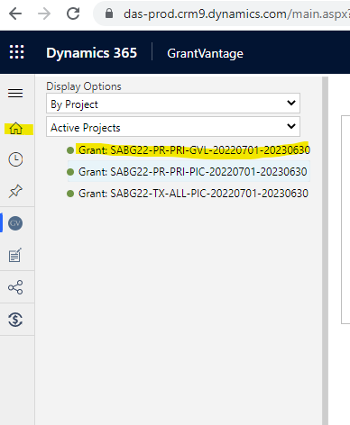

- After double clicking, the below screen will appear as the start pad for managing your grant. Single clicking the drop-down arrow on “Related” will lead you to single click on your “Objectives”
  - 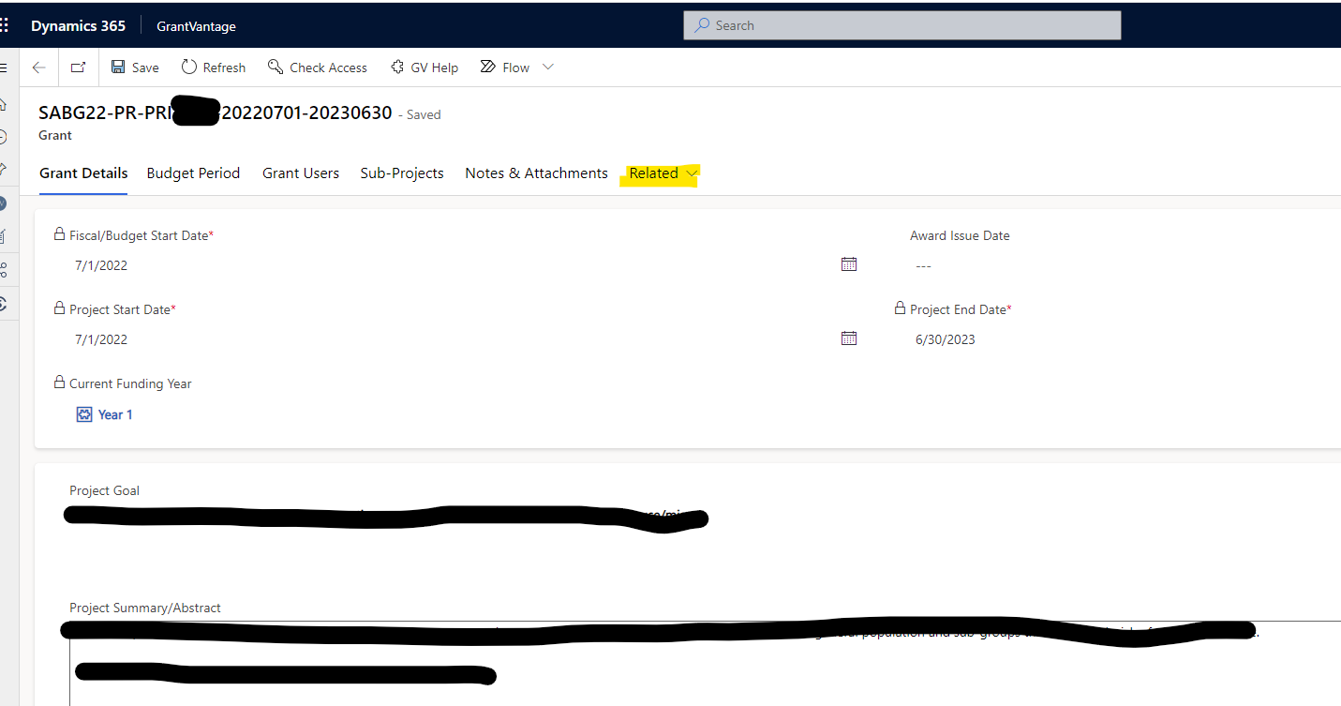
  - 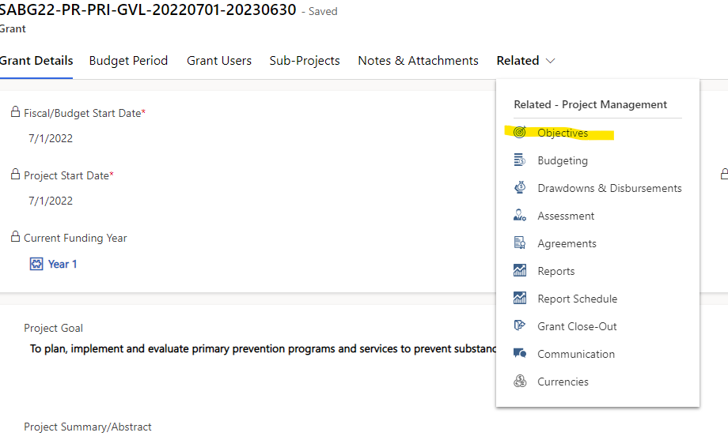
- Below the “Goal Name” for your agency, single click on the preferred goal name. as you hover your mouse to click, the goal will turn light blue in color.
  - 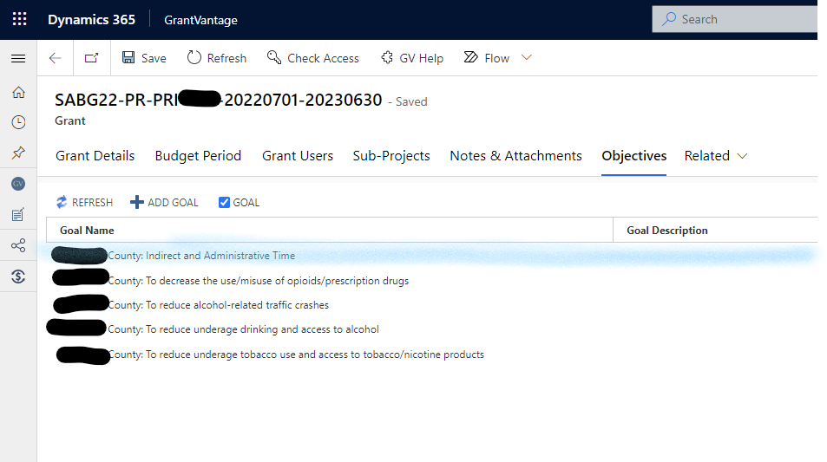
  - Single clicking on the selected goal will drop down the objectives listed under that goal.
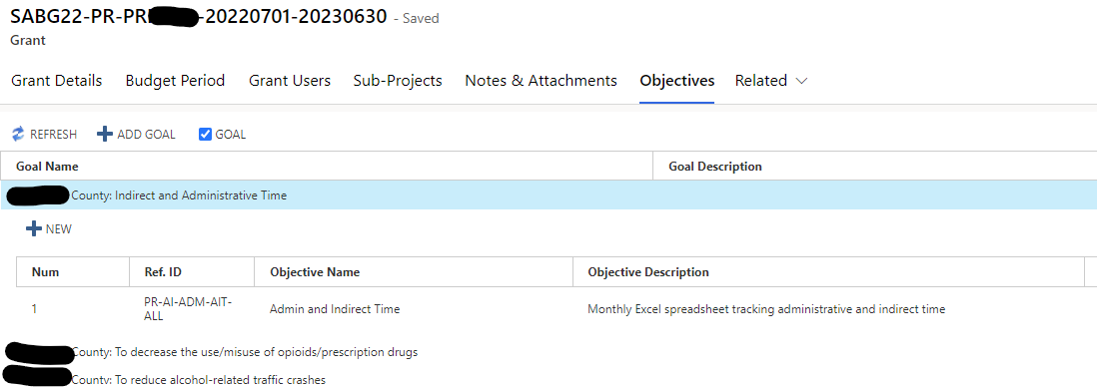
- Single click again on the objective you prefer. For this example, that objective name is “Admin and Indirect Time”
  - 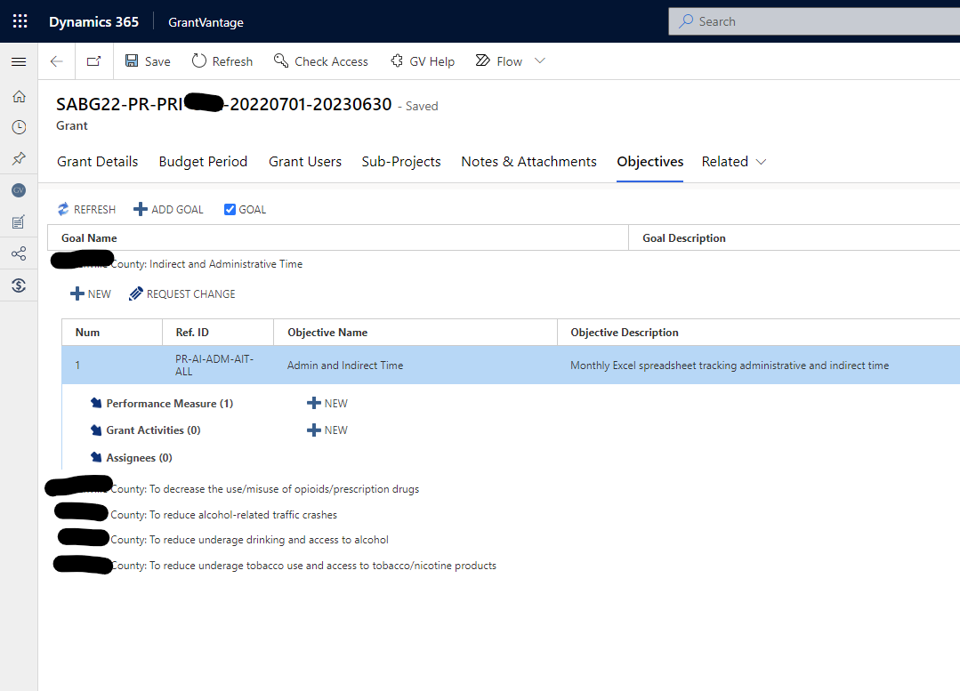
- After selecting your objective, another drop-down menu appears with performance measures, grant activities, and assignees. Single click on “Performance Measures” to drop down the measures that relate to that specific performance measure.
  - 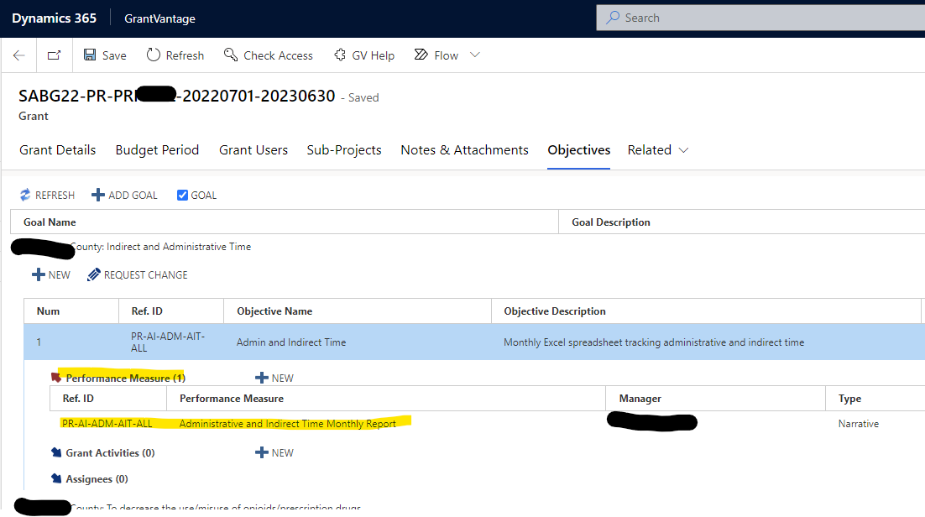
- Double click “Performance Measures” to manage them.
  - A new window will appear in the tab you are currently in.
  - For this specific objective, you will attach your monthly report by month name in the “Attachment” tab.
  - For all objectives, the same method applies for single or double clicking to navigate you to the reporting window for each performance measure.
